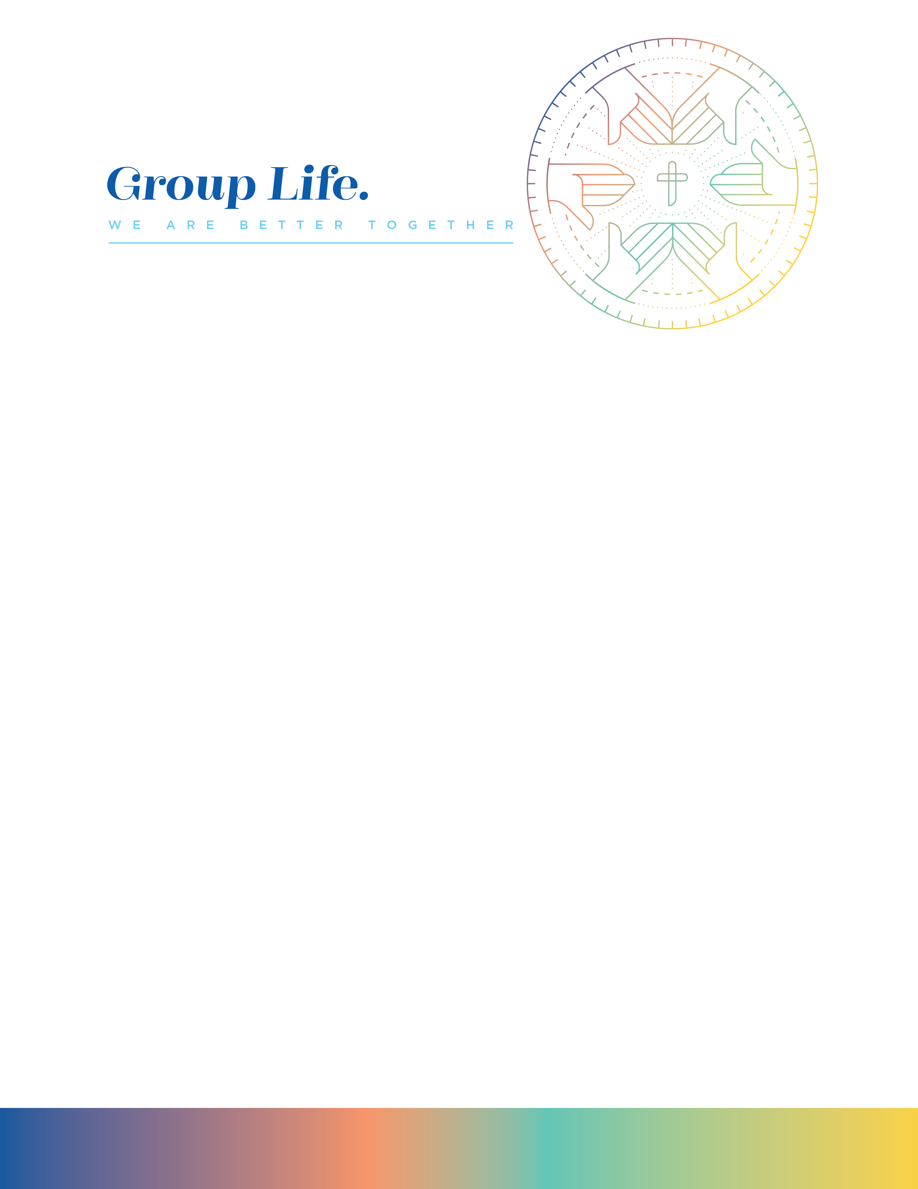

ICEBREAKER (10 MINUTES)
What is the last thing you have built or seen built? (Examples: Furniture, a Business, Lego set, etc.)

INTRODUCTION (5-10 MINUTES)
Anchor Verses: 2 Peter 1:11
This week we will dive into the why behind it as we look at the role sanctification plays in our entrance into the eternal kingdom promised to those who put their trust in Jesus.

INTO THE WORD (25 MINUTES)

- Read Romans 6:22, 1 Thessalonians 4:3, and Titus 2:11-13. The building blocks we have been studying are tools for us to be set apart. What sticks out to you from these passages about the idea of being set apart or, as C.S. Lewis says, being made into “Little Christs?”

- Read 2 Peter 3:13, John 14:2-4, Revelation 7:16-17, and Revelation 21:4-6. We know that the eternal Kingdom Peter talks about is a real place. What sticks out to you from these passages about what heaven will be like?

- Read 2 Peter 1:3-4, Matthew 6:10, Luke 17:21, and Romans 14:17. Jesus wants to make his kingdom in each one of us. What sticks out to you from these passages about how and why we are to live now?

APPLICATION (25 MINUTES)

- Read 1 John 3:6, Romans 6:1-2, and John 8:31. As you reflect on how you spend your time and energy, what does your foundation actually look like?

- Read Isaiah 53:6, Galatians 2:20, and Romans 8:1-11. After reflecting on your foundation, what would it look like for you to actively build to be a part of God’s Kingdom this week?

- Read 2 Peter 1:10-11, 2 Corinthians 5:17-21, and Revelation 1:5-6. What would it look like for your life to be drawing others into the Kingdom of God?

PRAYER (10 MINUTES)

Dear heavenly Father, thank you for richly provided for us by providing an entrance into your eternal kingdom. May we become more like you as we cultivate and dedicate our lives to reflecting you to the world around us. Thank you for preparing a place for us in heaven, and thank you for allowing us to play a piece in what you are doing here on earth. We pray all these things in Your excellent name. Amen.

